–

Plan and Schedule

ECE458 Senior Design Project, Spring 2020  
Project: Acoustic Awareness Enabler

February 4, 2020

University of Massachusetts Dartmouth

385 Old Westport Rd, Dartmouth MA 02747

Group 9

**Advisor:**

Dr. William McCollough

**Customer:**

Dr. Karen Payton

**Contributing Members:**

Drew Martins, Team Lead

Michael Benker

Jared Alves

Stephen Felix

Ryan Dumont

**Outline**

1. System Overview
2. Concept of Operations
3. System Block Diagram
4. Software Diagram
5. Hardware Diagram
6. Engineering Requirements
7. Updated Engineering Requirements Table
8. Schedule for Spring 2020 Semester

**SYSTEM OVERVIEW**

Concept of Operations

The concept of operations has remained mostly unchanged from the Preliminary Design Review. The full demonstration was included in the PDR presentation, which contained the following high-level diagram. The Concept of Operations lays out the basic idea behind the Acoustic Awareness Enabler. The top row of images illustrates the button interface and connection to auxiliary ports on the device to both the headphones and audio source. The three circle buttons indicate the sensitivity threshold to the interrupt level that will trigger the device to mute the audio and a manual button that will reset the device. The bottom row illustrates the various sensitivity levels that could trigger an interrupt from the device. The images show an example of a sound that could apply for each sensitivity level.

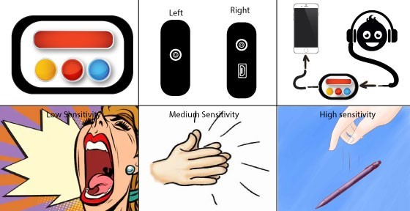

**Figure 1 – Concept of Operations**

Concept Design

The concept design schematic demonstrates the actual layout and interconnects of the device. Two 3.5mm auxiliary ports are used to connect both the audio source and headphones to the Acoustic Awareness Enabler. A five-button interface is used to interact with the device. The sensitivity level is selected along with a reset button to resume sampling the environment after an interrupt occurs. The built in ADC on the microcontroller is used to convert the signals picked up from the environment to data that the microcontroller processes. The microcontroller interacts with the switches to decide whether audio is passed from the environment or the sound source to the headphones.

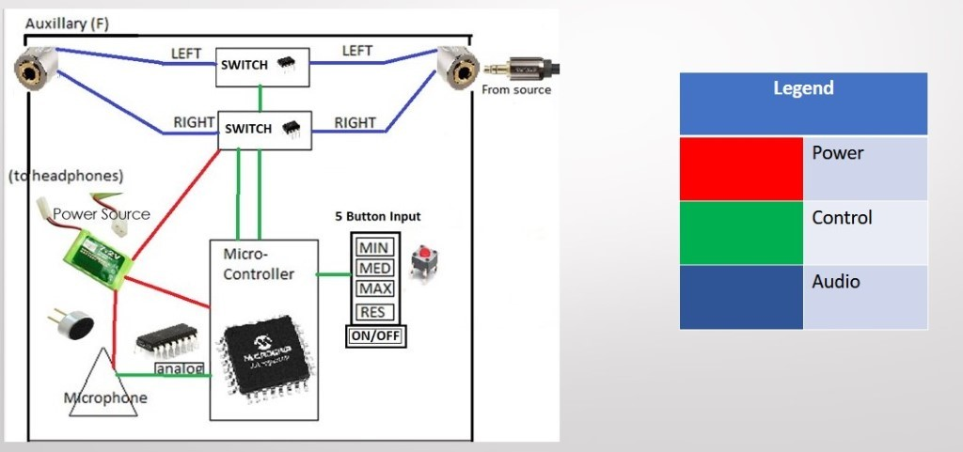

**Figure 2 – Concept Design Schematic**

Software Diagram

The main goal of the Digital Signal Processing side of the project is to compare a twenty second average to continuously monitored two second averages to check if an interrupt has occurred. The program is implemented using C programming language. Additionally, MATLAB is used to construct a software framework to test random data sets. The software diagram illustrates the concept for the program. The program is intended to take both a twenty second average and several two second averages. Successive averaging will be used due to restrictions of the 10-bit ADC. The original software diagram showed a standard deviation for both the two second average and the twenty second average. The new diagram illustrates a standard deviation of the two second average from the twenty second average in order to gauge whether an interrupt has occurred. Two decisions are made within the program: determining whether the standard deviation of the two second average from the twenty second average is greater than a specified value or not and whether the reset button is activated or not.

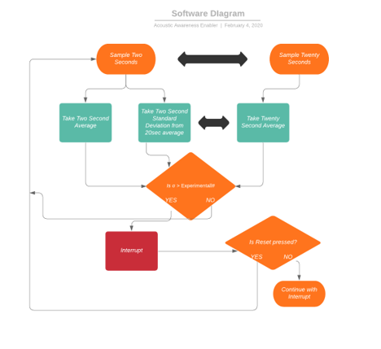

**Figure 3 – Software Diagram**

**Engineering Requirements**

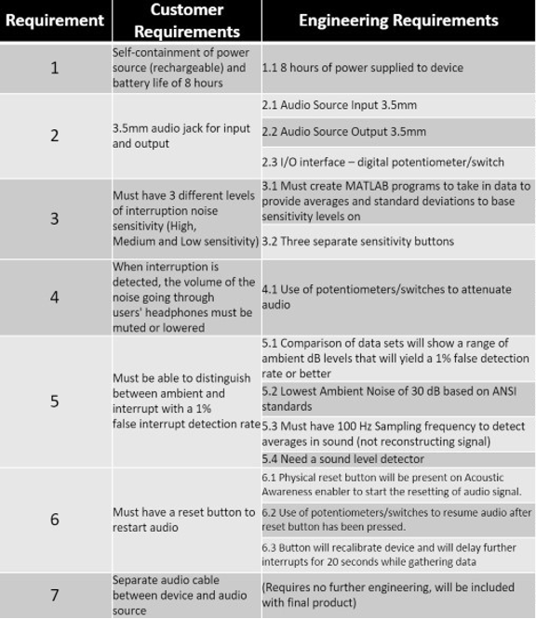The engineering requirements displayed above have remained the same from the PDR. It is not expected that any additions will be included for the upcoming semester. There are fourteen total engineering requirements to fulfill based upon seven customer requirements.

**Figure 4 – Engineering Requirements**

**Schedule for Spring 2020 Semester**

**Figure 5 – Plan and Schedule Part I**

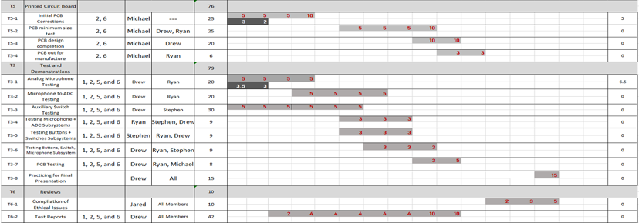

**Figure 6 – Plan and Schedule Part 2**